
Form 1 Integrated Science
Language Exercise

Class: Class No. Name:
3.2 A New Life is Born (2)
A. Vocabularies: copy the vocabularies five times in the boxes below.
female reproductive system |  |  |  |  |  | 女性生殖系統
ovaries |  |  |  |  |  | 卵巢
uterus |  |  |  |  |  | 子宮
oviducts |  |  |  |  |  | 輸卵管
vagina |  |  |  |  |  | 陰道
fertilized egg |  |  |  |  |  | 受精卵
fertilization |  |  |  |  |  | 受精作用
embryo |  |  |  |  |  | 胚胎
uterine lining |  |  |  |  |  | 子宮內膜
implantation |  |  |  |  |  | 植入
placenta |  |  |  |  |  | 胎盤
umbilical cord |  |  |  |  |  | 臍帶
amnion |  |  |  |  |  | 羊膜
amniotic fluid |  |  |  |  |  | 羊水
foetus |  |  |  |  |  | 胎兒
labour |  |  |  |  |  | 分娩
B. Fill in the blanks: choose the suitable vocabularies in p. 1 and complete the sentences below.

(1) Label the structure of the female reproductive system shown in the diagram below.


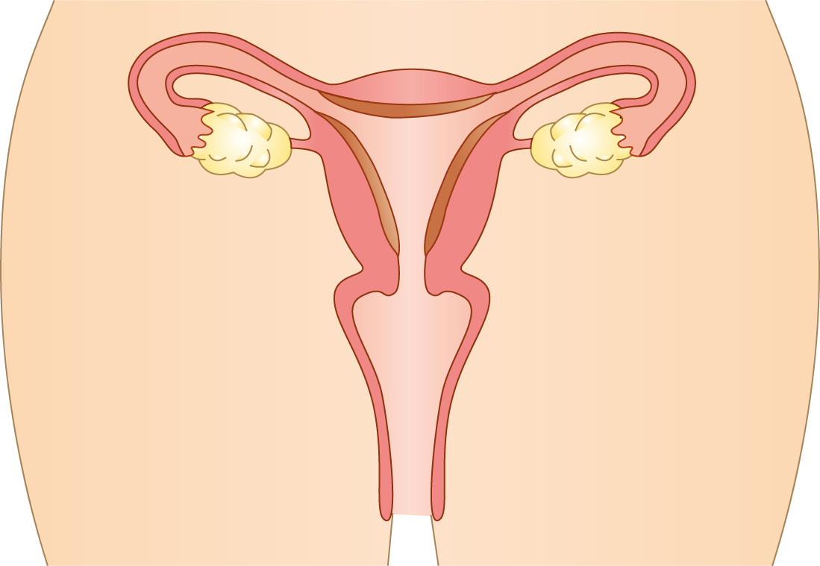

(2) The functions of ____________________ is to carry the egg to the uterus.

(3) When a sperm fuses (融合) with an egg, a ____________________ ____________________ is formed. This process (過程) is called ____________________.

(4) The process of an embryo becoming embedded (嵌進 ) in the uterine lining is called ____________________.

(5) The diagram below shows an embryo developing in the uterus. Label the different parts.
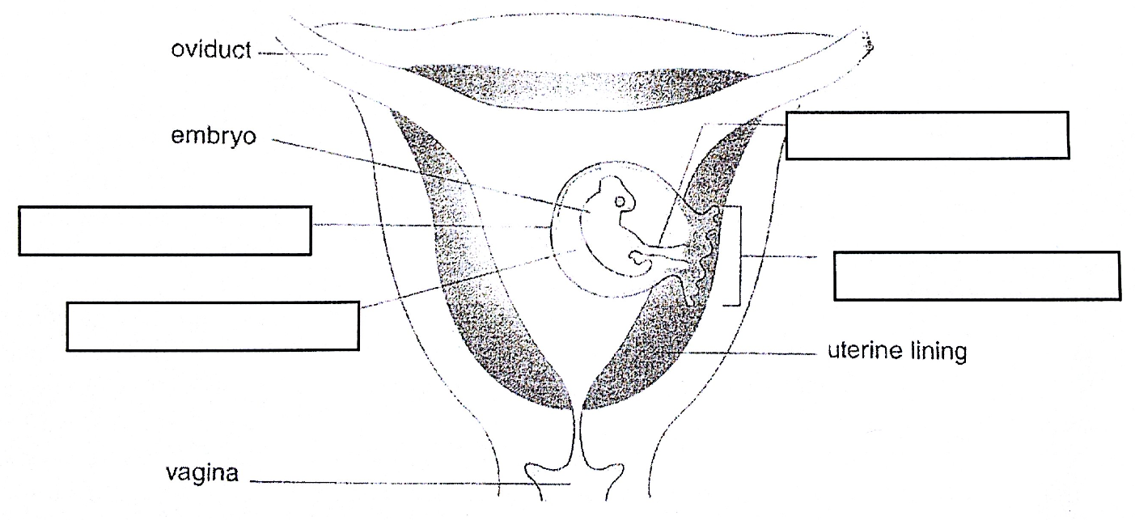
(6) During ____________________, the muscles (肌肉) of the uterus contract (收縮) strongly to push the foetus out through the ____________________.

